**Gourmet Express – Process Control Workshop**

To illustrate the application of a process control and improvement technique such as lean six sigma and in particular the DMAIC tool we have chosen to use a relatively straightforward and simple scenario based on the Gourmet Express.

**Scenario**

To make a batch of final product, 15kgs of scallops are used in the Bratt Pan 3 cook. The process of ensuring 15kg of scallops are obtained they are put into a plastic container until the ‘fill line’ has been reached. This ‘fill line’ has been calibrated and therefore the process considered to be valid by, on a few occasions the scallops used to reach the fill line having been subsequently weighed. On each occasion it was reported that 15kg had been achieved and on that basis it was determined the process was valid. No subsequent verification activity was considered necessary and the scallop batching process has remained unaltered since.

The master ingredients list shows the quantity of each ingredient by weight which makes up the Broth, Rouille and Final Cook.

Following a change in senior management the Gourmet Express adopted lean six sigma methodology and the Technical section were instructed to use the DMAIC tool to optimise production – in particular minimise process errors (out of tolerance results) and needless expenditure. Furthermore they were invited to use statistics to quantify the extent of any production gain.

The tutor is to show delegates the variability in the current methodology for measuring scallops by reference to the graph below, explain the probability of failure (i.e. of achieving a weight below 15kg) and therefore illustrate the opportunity and need for process improvement.

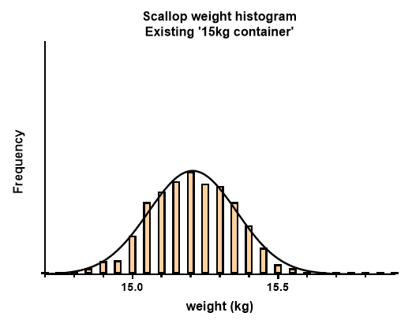

***Objective***

*Knowing how each 15kg of scallops is quantified can you suggest any change to the measuring technique / equipment (without resorting to weighing) which would result in better process control or improvement. Can you also show how these changes would alter change the shape of the bell curve.*

**Tutor to discuss when feeding back**

Through this study it was possible to quantify and reduce error rates, but in this case it has been determined that the only way to achieve the 6 sigma objective, i.e. no more than 3.4 errors in a sample size of a million, would be by weighing every 15kg batch of scallops. As the company didn’t want to buy additional scales or dedicate more operator time to weighing they are happy are happy with the error rate which has resulted by using a new container which is slightly more cylindrical (smaller open circumference) than the existing container.

There are four graphical illustrations ….

1. Original scallop container which is the one used during the validation study, but on this occasion a much larger sample size was used. This could also have been predicted from working out the mean and standard deviation from the validation study dataset (sample size = 40). This shows there is an approx. 8% chance of the container holding less than 15kg of scallops.
2. Then to optimise the process we used a different fill line on the scallop container and this shows the probability of the scallops being less than 15kg of 0.41%. However the down side of this is there still remains the same standard deviation as with option 1 and so product is used unnecessarily.
3. Then the technical manager came up with the idea of using more of cylindrical container and this returned a 0.6% probability of the total weight falling below 15kg, however the graph is very useful in demonstrating a significant improvement in process control and a much reduced probability of using too many scallops thereby incurring unnecessary expense.
4. The final graph is shows the probability of the 15kg of scallops being achieved is significantly improved, but this container while it has a small open surface area and allows better packing of scallops is very difficult to handle and to adopt its use would only introduce health and safety issues. With this, albeit unworkable option, the probability of less than 15kg being used is 0.05%.

So the best option to optimise the process is taking into account all relevant factors is option 3. The histogram graphs illustrate this.